Python Excel

First install the package openpyxl

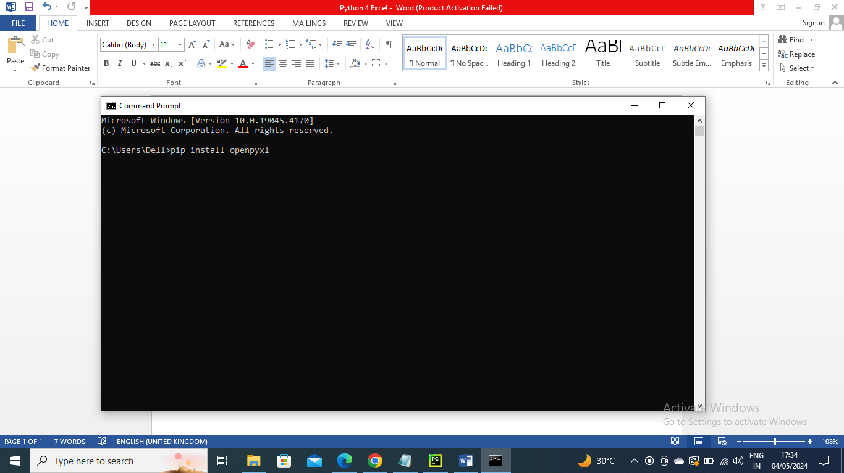

Below is the program to read each cell i.e. row and column from excel file

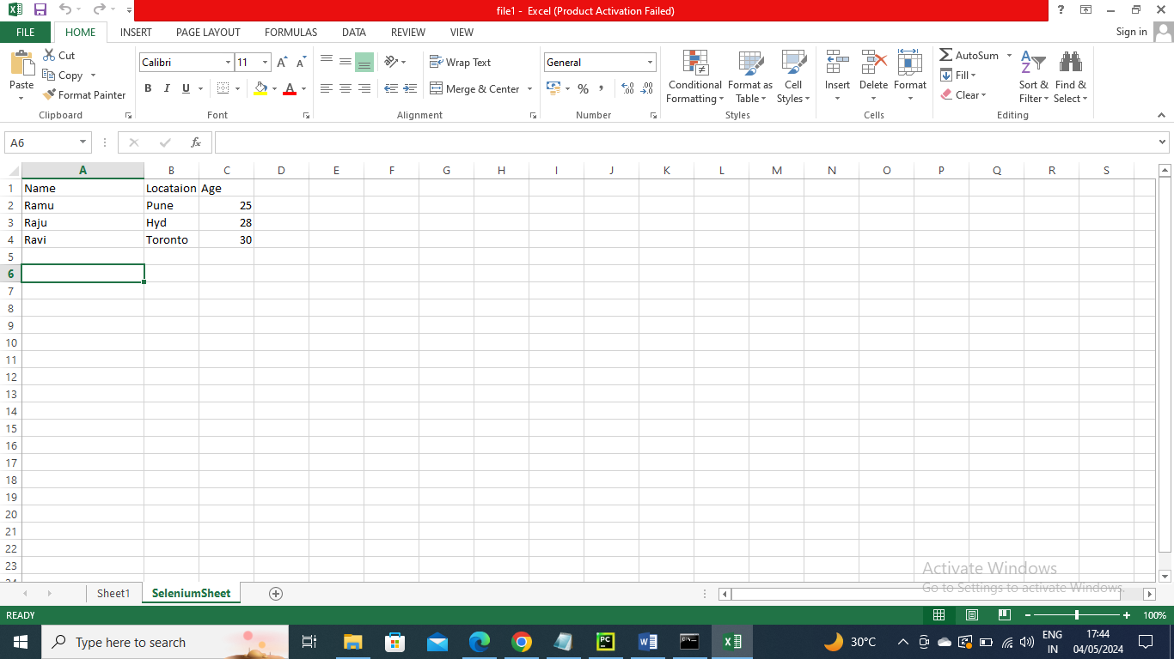

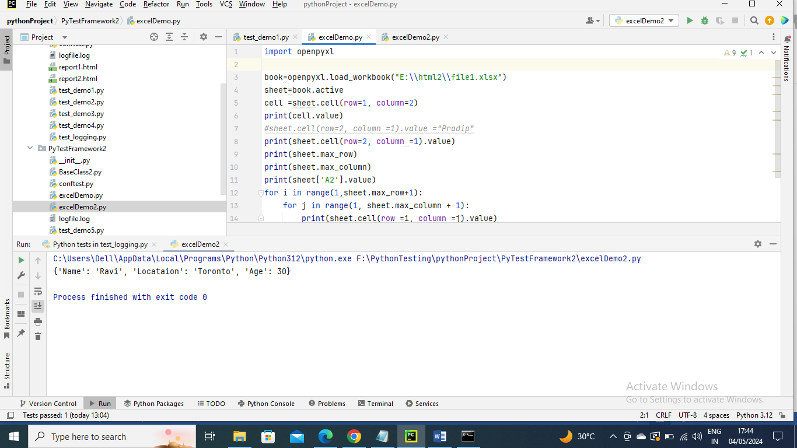

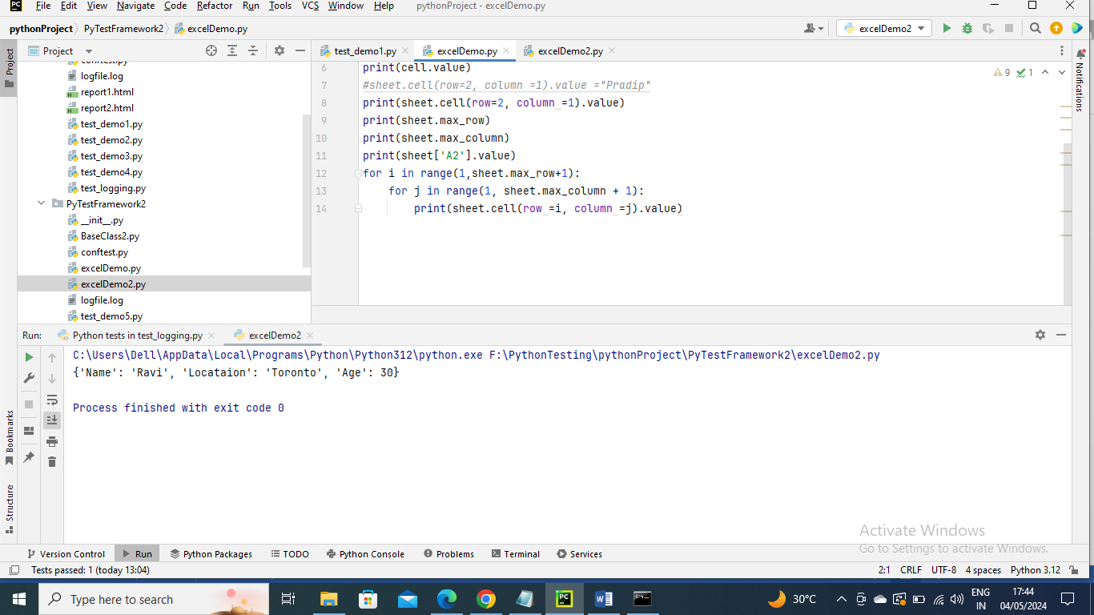

Below is an example where moving the data into data dictionary

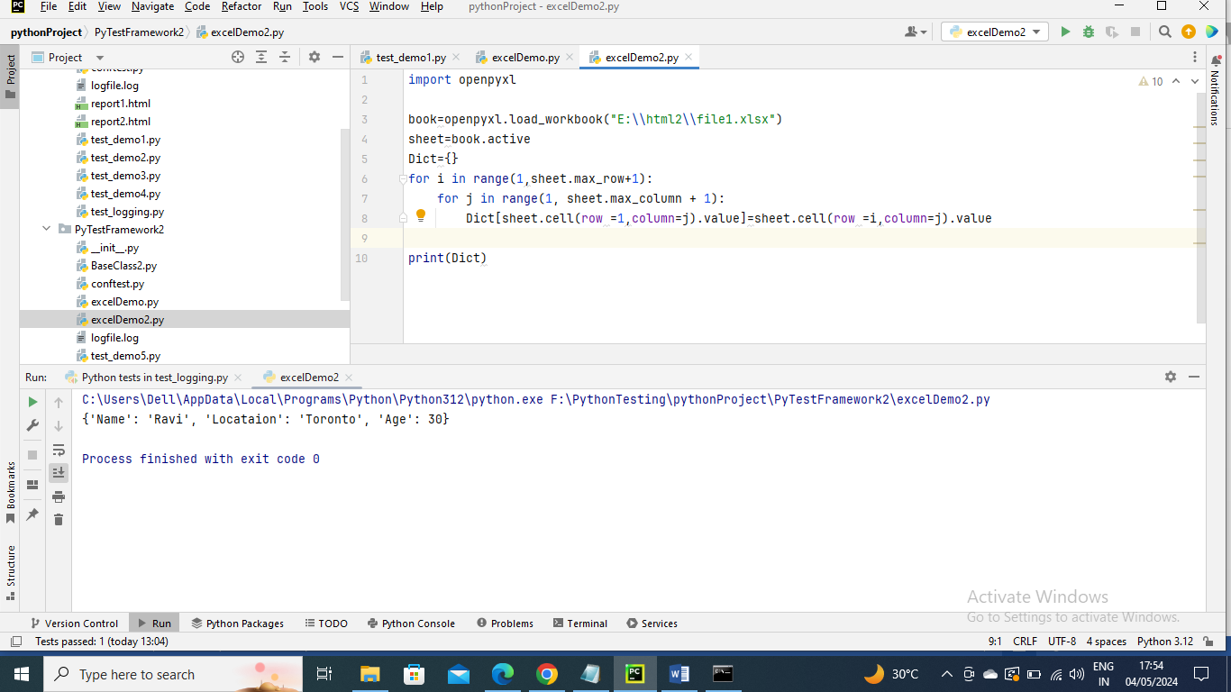

----------------------

Now lets’s use data taken from excel in Python selenium

The below fixture DataLoad gets the data from excel and stores in Dictionary and sends to whoever using it

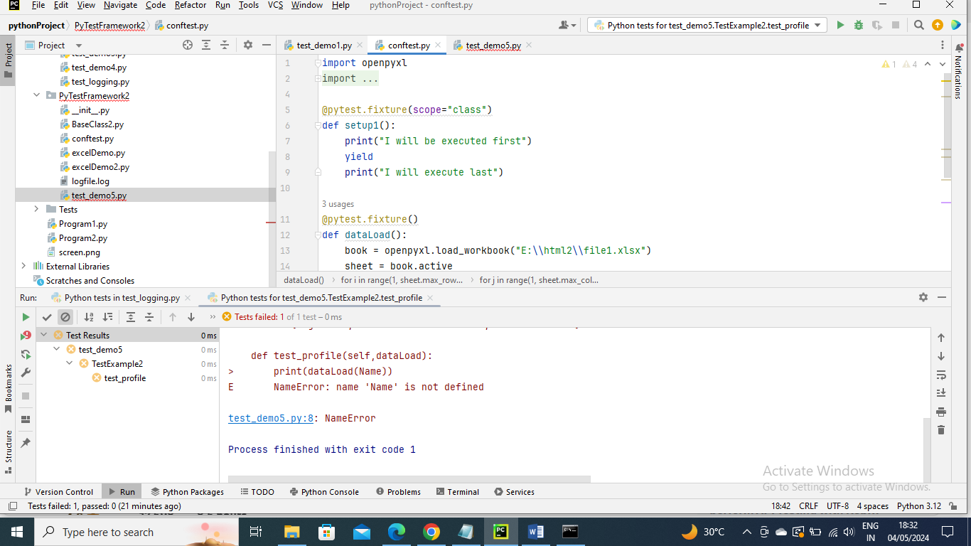

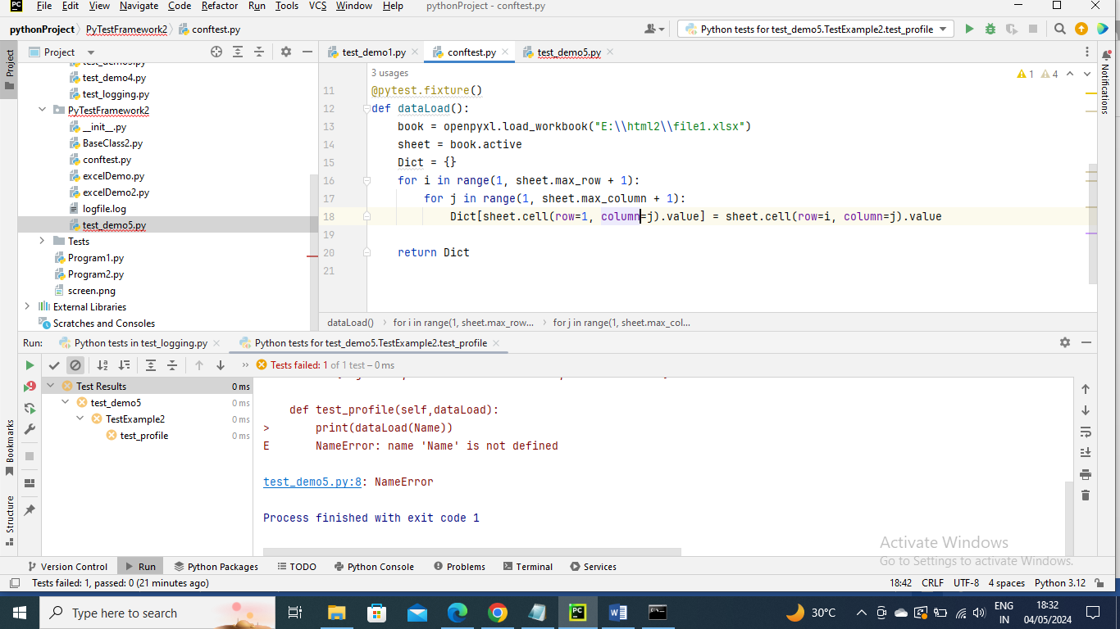

The below program method uses fixture and the data is accessed

